The Only Candlestick Patterns Trading.
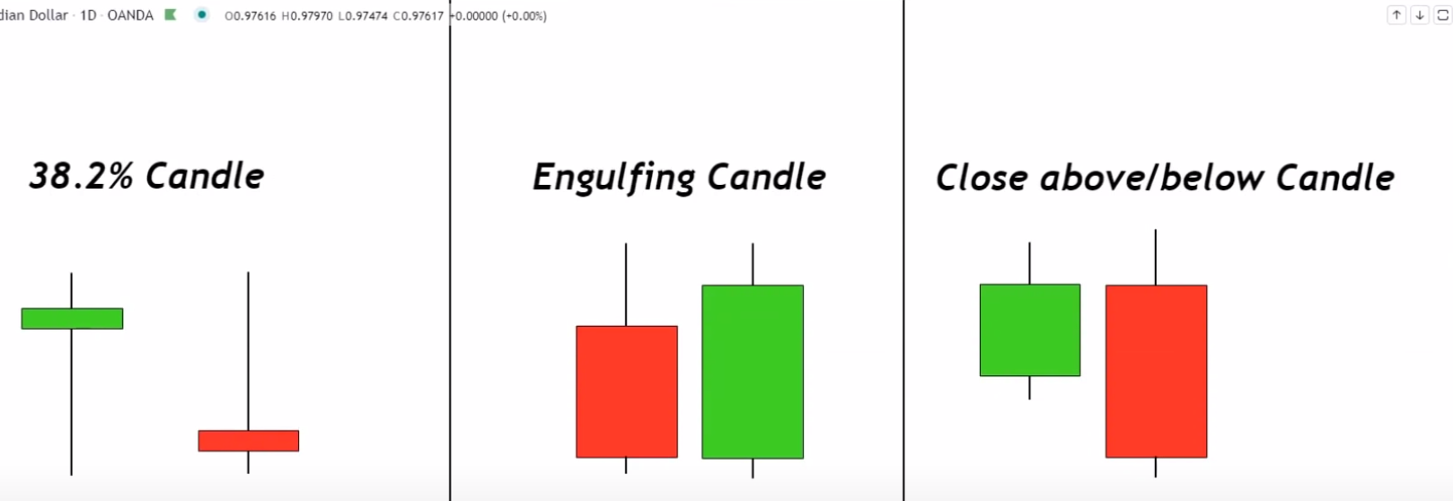
Bullish Red and Green candle.
Hammer candle can be RED or GREEN

- Identify the 38.2% candle pattern in an objective way using a fibonacci retracement from the top of that candle down to the low and as long as the entire body of that candle is below the 38.2% etracement then i know that as a selling pressure.
- Identify the 38.2% candle pattern pull a fibonacci retracement from the swing low of the candle itself to the high of the candle itself as long as the entire body of that candle is above the 38.2% retracement then i count this as a valid 38.2 percent candle and i count this as a candle that's showing me buying pressure.

NOTE:
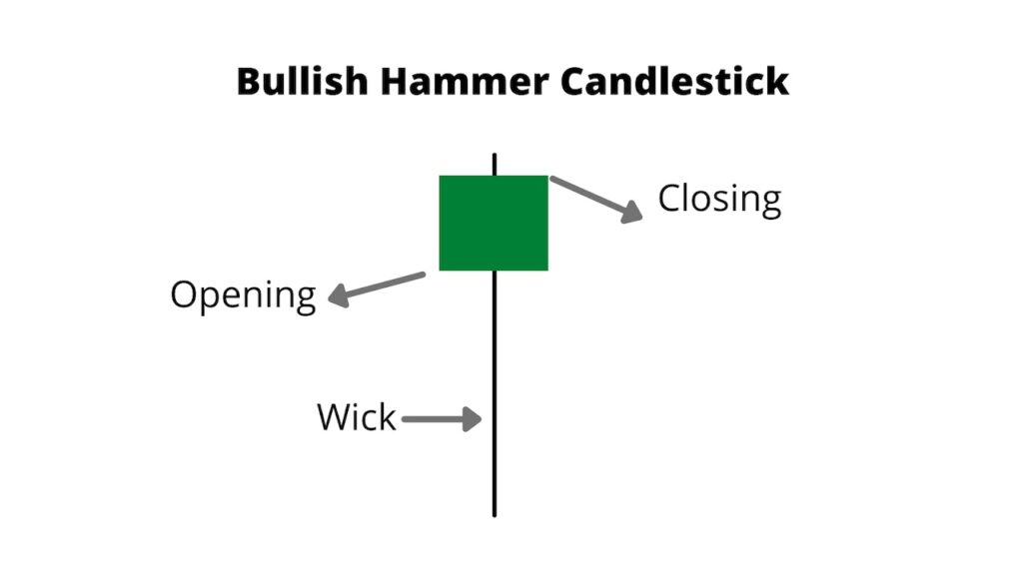
The way we use these types of candles 38.2% is if this was to occur at the top of an uptrend
it might be a sign of a reversal, if this was to occur in a downtrend on our pullback it might be a sign that we're about to continue in trend.
NOTE: The HAMMER “38.2% “ CANDLE can be RED or GREEN.
Combing this candle stick in a major area of value can give a good results at times.

- Engulfing candle is a candle that has a larger body than the previous candle and that changes colors. so for a bullish engulfing pattern i need to see that

- The previous candle was red that the next candle is green and that the green candle has a larger body than the previous candle that is a bullish engulfing candle for me.
- The bearish engulfing pattern is the opposite of bullish.

Trading the 38.2% candle patterns Bullish version
Conditions.
- We're going to be using the 20 period moving average.
- price must be trading above that 20 period moving average
- Wait on 38.2 percent candle (price) to touch the 20 period moving average and wick off.

Entry rules:
The close of that 38.2 candle is our entry and then we put stops and targets accordingly.
STOP: 20 pips below the low of the entry candle.
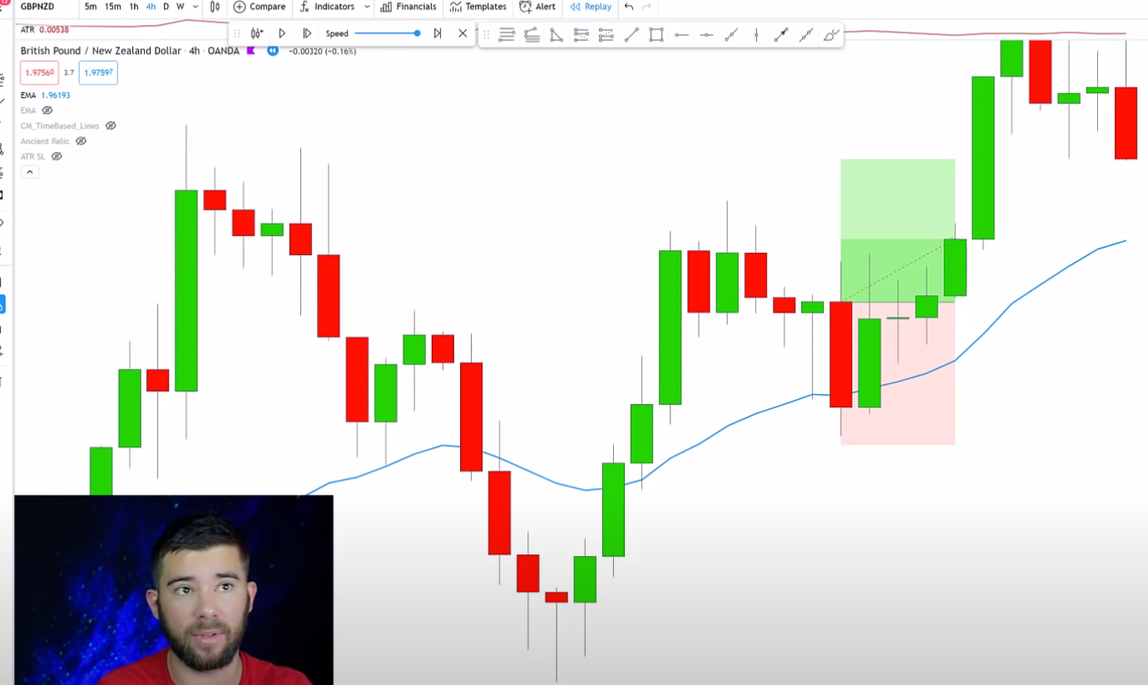

Bearish version

Conditions.
- The market is trading below the 20 period moving average.
- Wait for a candle to touch the 20 Moving average then wick off of the 20-period moving average.
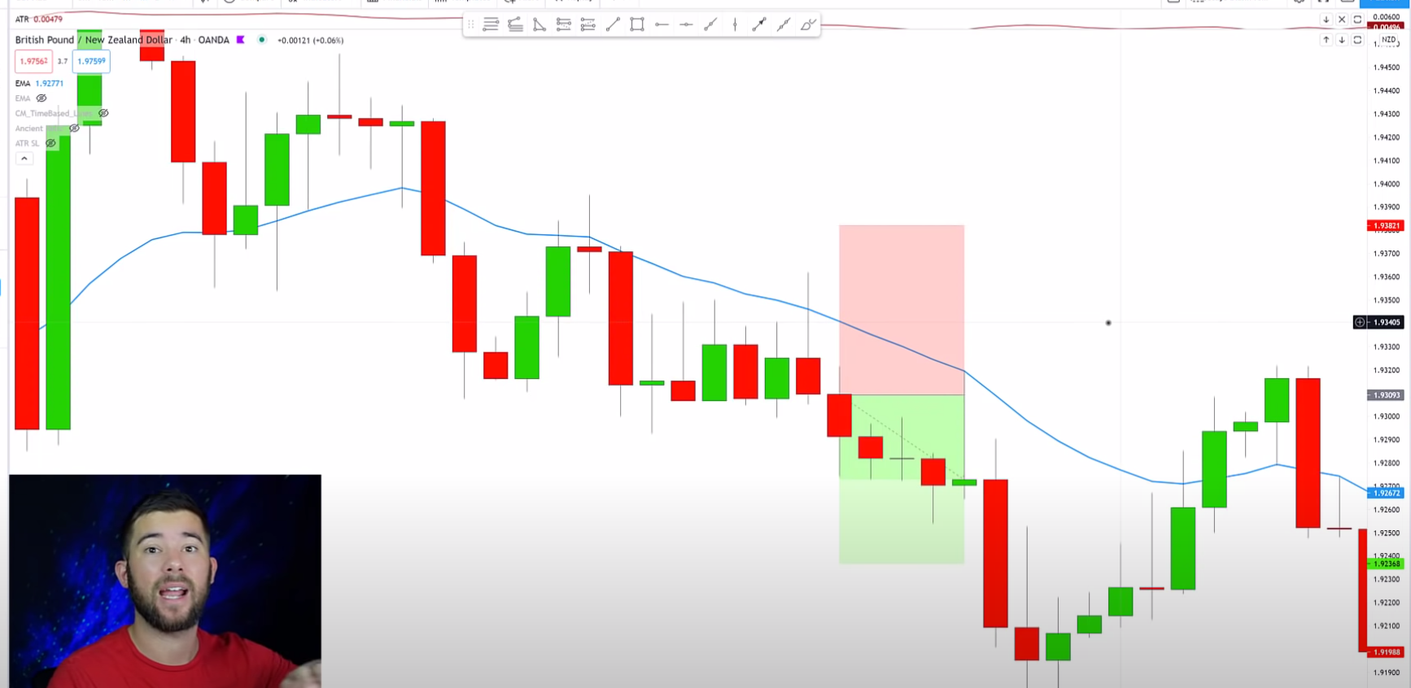

STOP: Our stop is going to be 20 pips above 53 plus 20 = 73, and then we have a one-to-one reward to risk ratio

